**User Guide**

***‘Provisions Du Sud’***

Web Application

Done by: Hussein SAAD

Summary

Table des matières

1.Sign Up 3

2.Log In and Log Out 4

2.Choosing Products 5

a. Go to the Products page first of all: 5

b. Scroll down to look for products you are searching for: 6

c. Buying the Products: 6

3.Buying Products 7

# 1.Sign Up

Frist of all, have to create an account by pressing on Sign Up Now button



And if you are on a tablet or a phone the button will appear here

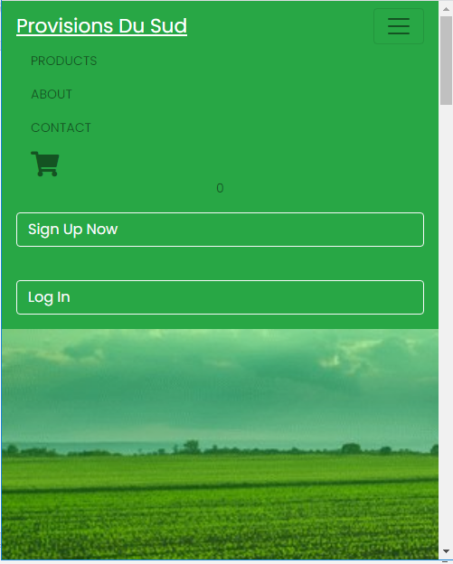

You have then to fill some information like your First and Last name, Email address and password and at after successfully filling the demanded information you hit submit button (the green button).

The password must be at least 6 characters and the email must be a valid email while you will be asked to confirm your password.

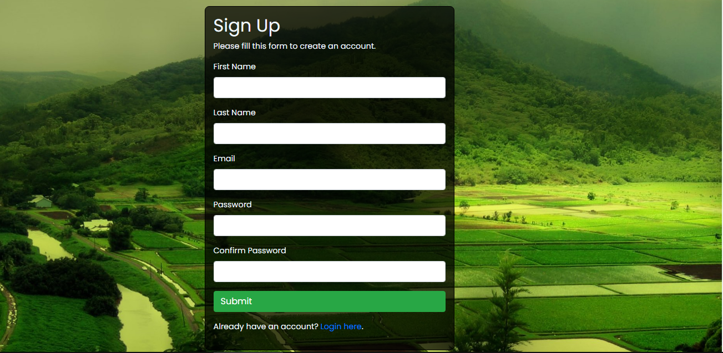

# 2.Log In and Log Out

After creating your account, you can log out from the site but hitting the log out button bellow



The next time you want to visit the site you can just log in using your email and password and then hit the log in button.

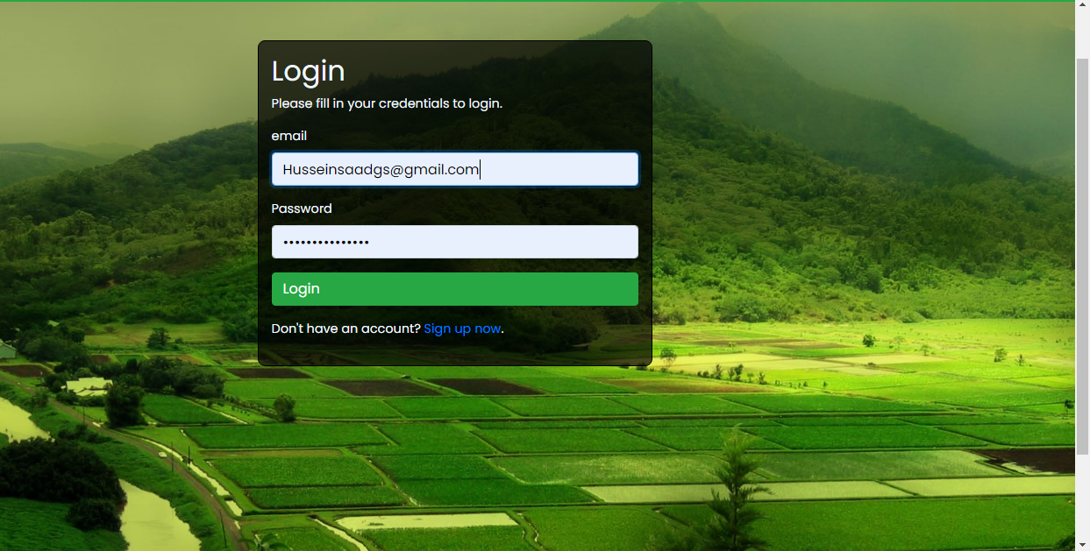

# 2.Choosing Products

## Go to the Products page first of all:

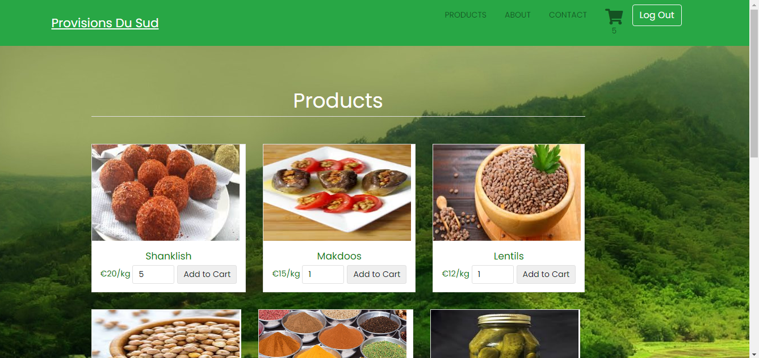

## Scroll down to look for products you are searching for:

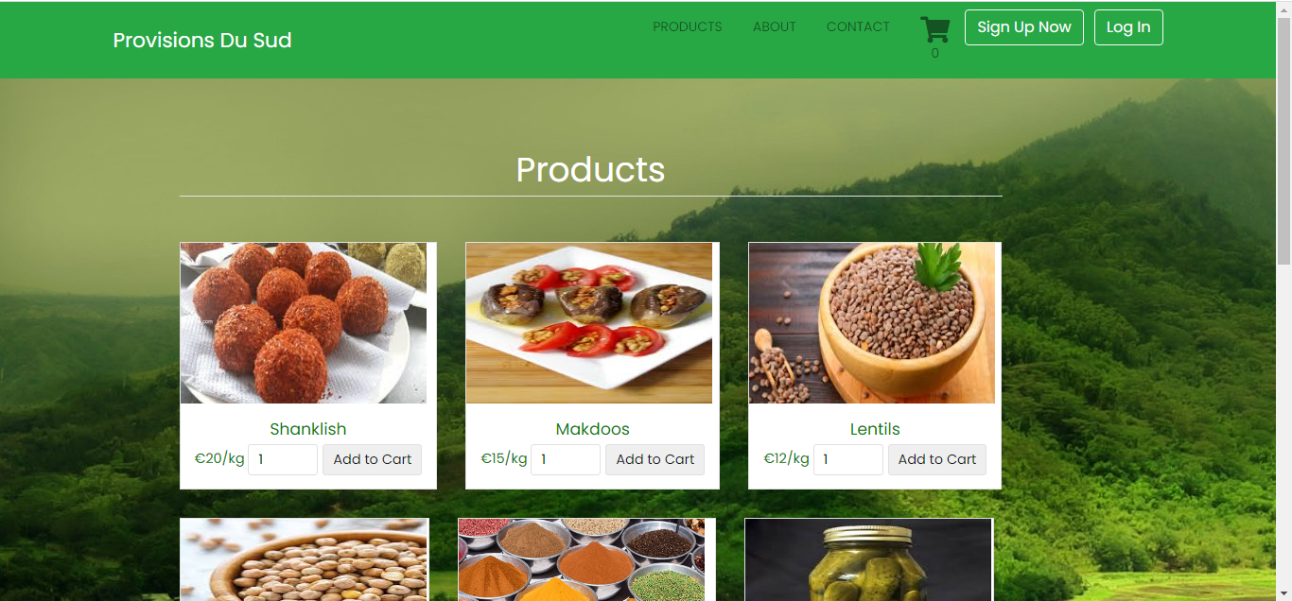

# c. Buying the Products:

i) choose the quantity in Kilograms

ii) press on add to cart button



ii)

i)Quantity

Here you can see the number of items you added to the shopping cart:



# 3.Buying Products

Now hit the Shopping cart icon to see what you have until now:



This is your shopping cart page now and it contains the products you want with their price

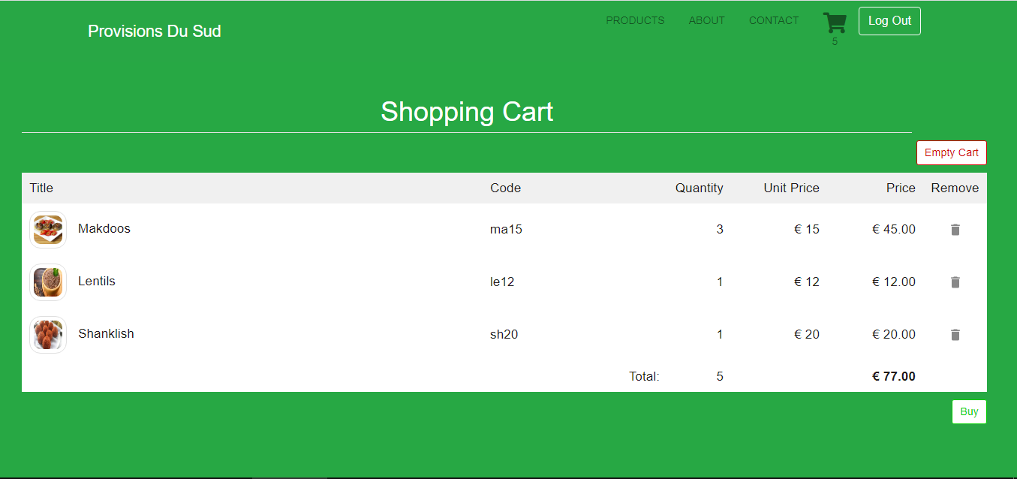

You can delete an item (by pressing the recycle bin icon) that you do not want or you can empty all the cart and start choosing products again.



Now after verifying that you added all products you want, you can hit the buy button



This will take you to fill a form containing the address of shipping and your name and email and after finishing click submit

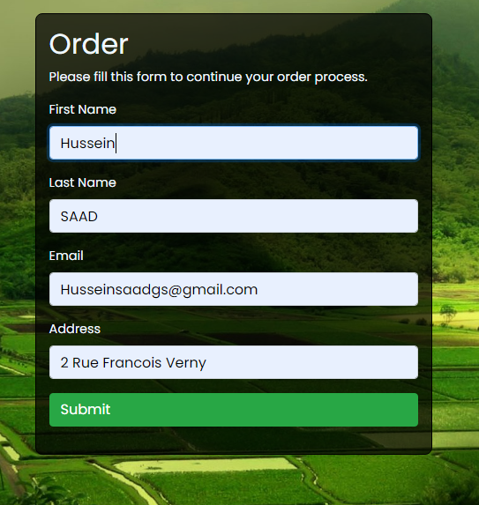

Now your order is sent to our database and we will send you an email including your invoice and shipping details.

Thank you for your Visit!